**LIT ASSIGNMENT -DAY 10**

**Name : Bharat Pratap Singh**

**EMPLOYEE ID – 46255429**

**Assignment 3 – Business Add in (BADI)-Single Use.'**

* Define a BADI (ZBADI_DEMO_01…05) in SE18.

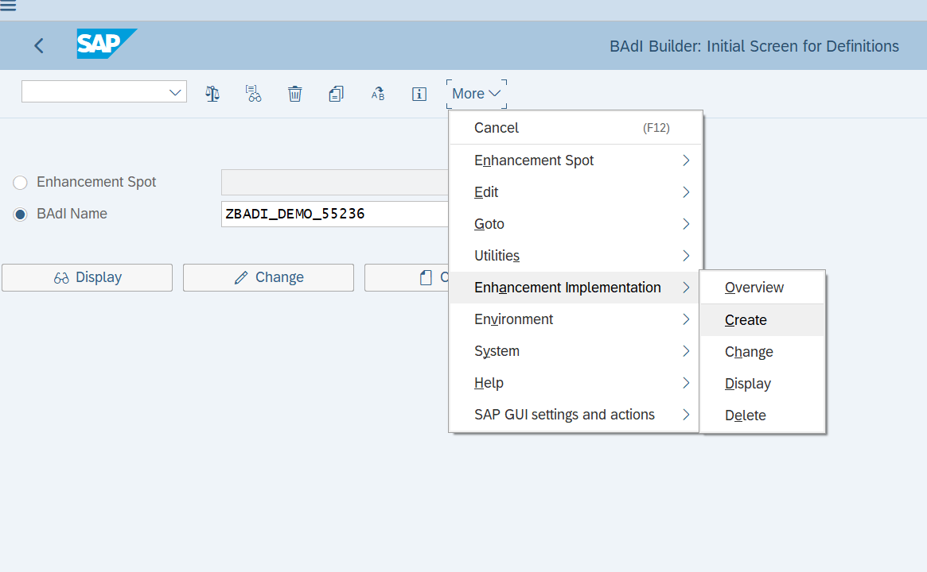   
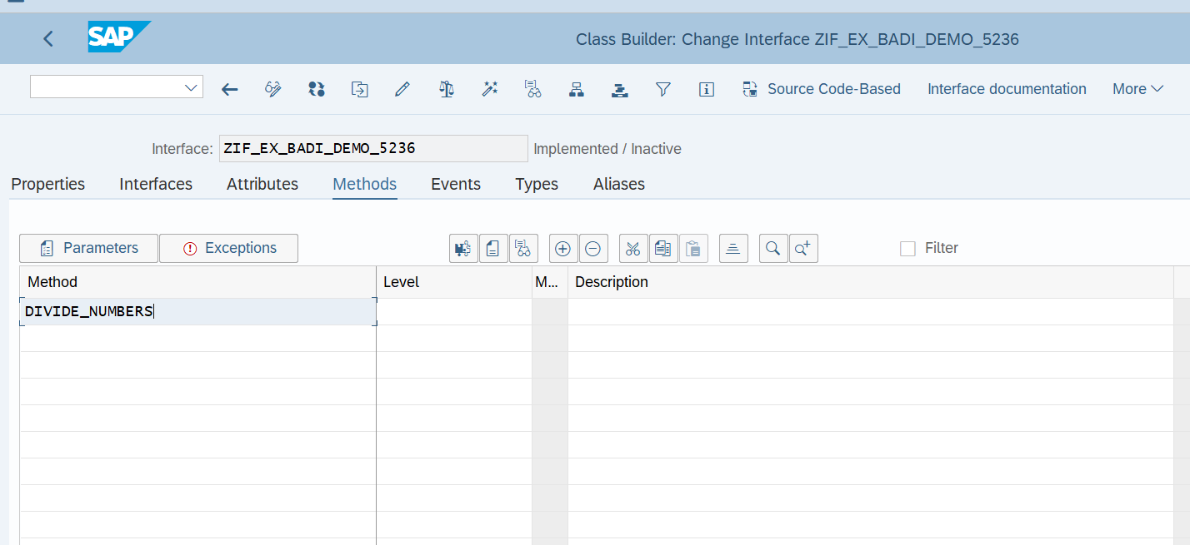   
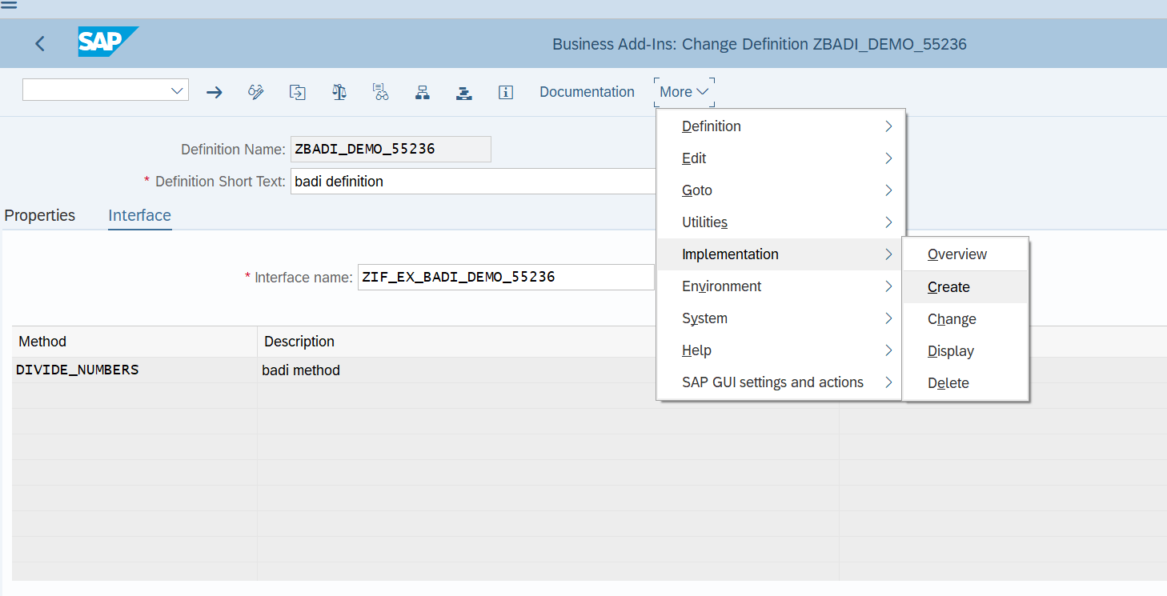   
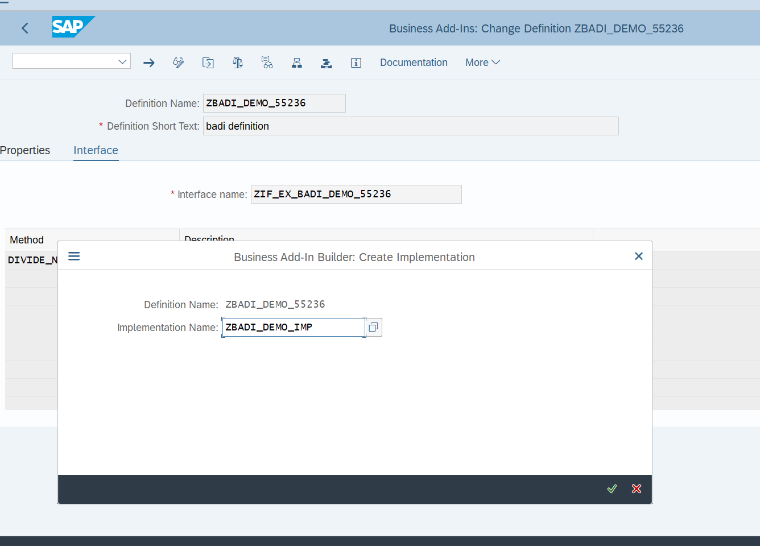   
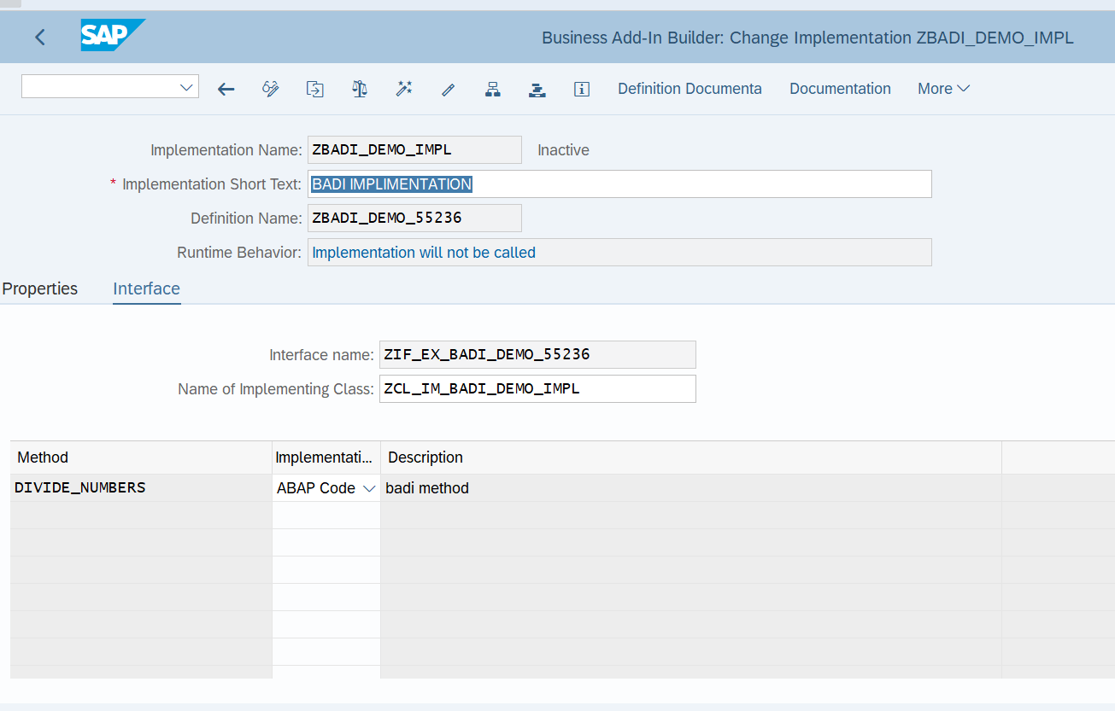   
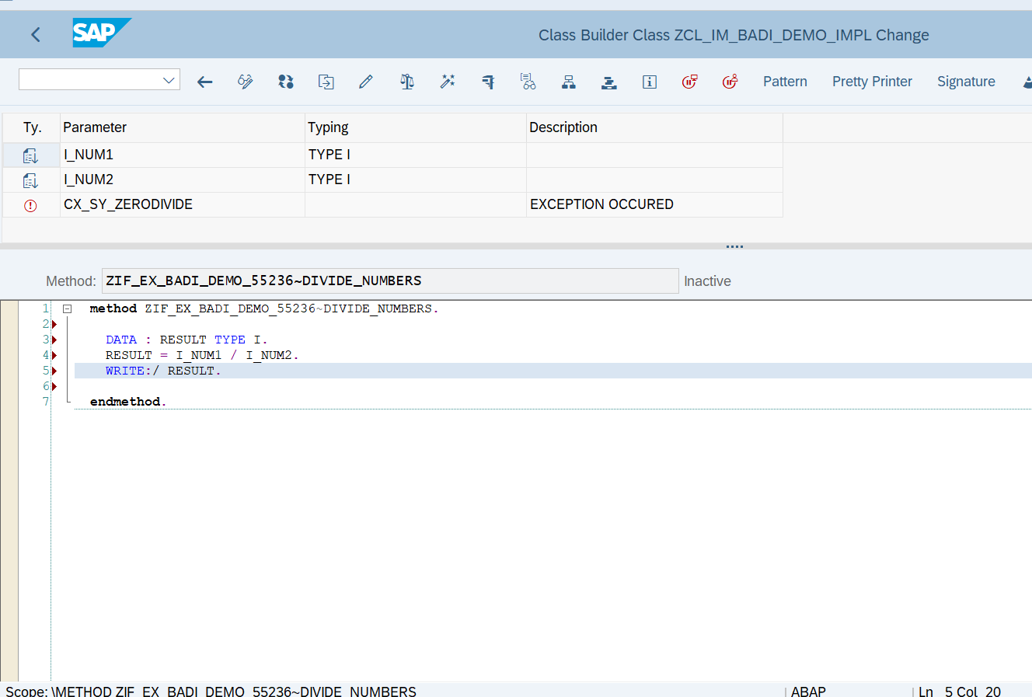   
REPORT Z415_BADI_DEMO.    
    
START-OF-SELECTION. CLASS CL_EXITHANDLER DEFINITION LOAD.    
DATA: RESULT TYPE I.    
DATA OBJ1 TYPE REF TO ZIF_EX_BADI_DEMO_55236.    
    
PARAMETERS: NUM1 TYPE I,    
            NUM2 TYPE I.    
    
CALL METHOD cl_exithandler=>get_instance    
  EXPORTING    
    exit_name                     =  'ZBADI_DEMO_55236'    
*\*    null_instance_accepted        = SEEX_FALSE*    
*\*  IMPORTING*    
*\*    act_imp_existing              =*    
  CHANGING    
    instance                      = OBJ1    
  EXCEPTIONS    
    no_reference                  = 1    
    no_interface_reference        = 2    
    no_exit_interface             = 3    
    class_not_implement_interface = 4    
    single_exit_multiply_active   = 5    
    cast_error                    = 6    
    exit_not_existing             = 7    
    data_incons_in_exit_managem   = 8    
    others                        = 9    
        .    
IF sy-subrc <> 0.    
*\* Implement suitable error handling here*    
ENDIF.    
    
TRY.    
  CALL METHOD obj1->divide_numbers    
      EXPORTING i_num1 = NUM1    
                i_num2 = NUM2 .    
 CATCH cx_sy_zerodivide .    
       
   ENDTRY.

OUTPUT:

Page Break

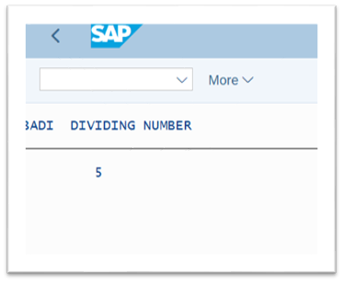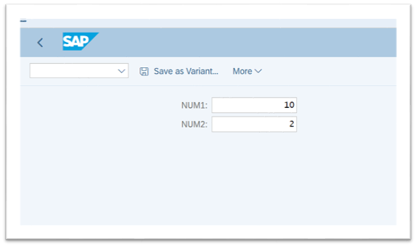



**Assignment 4 – Business Add in (BADI)-Multiple Use**

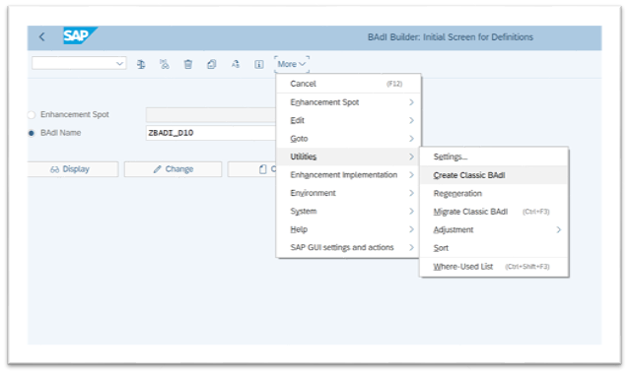

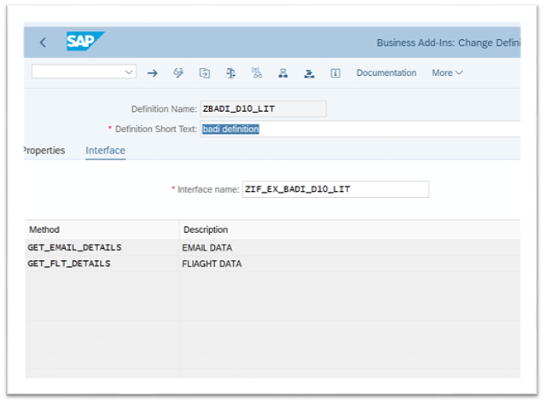

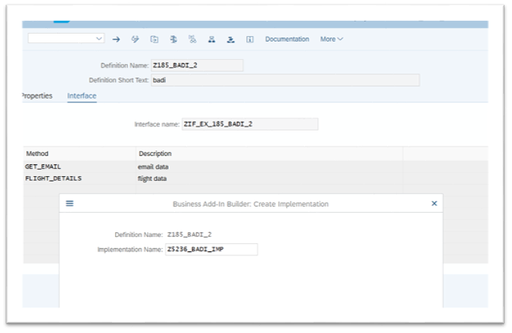

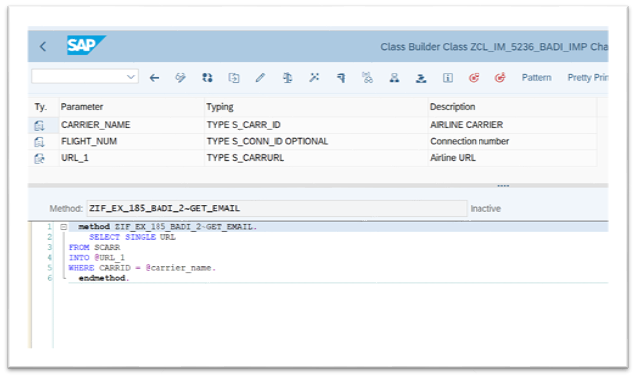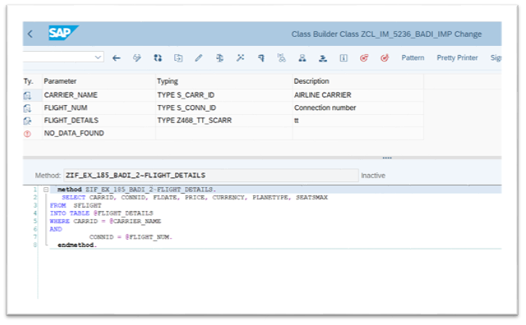

REPORT Z415D10.    
    
DATA: OBJ TYPE REF TO ZIF_EX_BADI_D10_LIT.    
    
PARAMETERS: p_carr TYPE S_CARR_ID,    
            P_flight TYPE S_CONN_ID.    
    
    
DATA : it_flight TYPE  Z468_TT_SCARR,                          *" declaring internal table of sflight*    
       gs_sflight TYPE line of Z468_TT_SCARR,    
       url type s_carrurl.    
CL_EXITHANDLER=>GET_INSTANCE(    
EXPORTING    
    EXIT_NAME                     =  'ZBADI_D10_LIT'   *" Business Add-In Definition*    
*\*    NULL_INSTANCE_ACCEPTED        =     " Is Null Instance OK if There Is no Active Implementation?*    
*\*  IMPORTING*    
*\*    ACT_IMP_EXISTING              =     " Returns an Active Implementation*    
CHANGING    
    INSTANCE                      =  OBJ   *" Instance*    
EXCEPTIONS    
    NO_REFERENCE                  = 1    
    NO_INTERFACE_REFERENCE        = 2    
    NO_EXIT_INTERFACE             = 3    
    CLASS_NOT_IMPLEMENT_INTERFACE = 4    
    SINGLE_EXIT_MULTIPLY_ACTIVE   = 5    
    CAST_ERROR                    = 6    
    EXIT_NOT_EXISTING             = 7    
    DATA_INCONS_IN_EXIT_MANAGEM   = 8    
OTHERS                        = 9    
).    
IF SY-SUBRC <> 0.    
*\* MESSAGE ID SY-MSGID TYPE SY-MSGTY NUMBER SY-MSGNO*    
*\*            WITH SY-MSGV1 SY-MSGV2 SY-MSGV3 SY-MSGV4.*    
ENDIF.    
    
CALL METHOD obj->get_flt_details    
  EXPORTING    
    carrier_name   = p_carr    
    flight_num     = p_flight    
  CHANGING    
    flight_details = it_flight    
*\*  EXCEPTIONS*    
*\*    no_data_found  = 1*    
*\*    others         = 2*    
        .    
IF sy-subrc <> 0.    
*\* Implement suitable error handling here*    
ENDIF.    
    
    
    
    
    
CALL METHOD obj->get_email_details    
  EXPORTING    
    carrier_name = p_carr    
    flight_num   = p_flight    
  CHANGING    
    url          = url    
    .    
    
    
    
WRITE: / 'Airline URL is' COLOR COL_POSITIVE,  url.    
WRITE: 40 'Flight Details' COLOR COL_POSITIVE.    
WRITE: / 'CARRID',    
10 'CONNID',    
20 'FLDATE',    
31 '      PRICE',    
52 'CURRENCY',    
63 'PLANETYPE',    
75 'SEATSMAX'.    
ULINE.    
LOOP AT it_flight INTO gs_sflight.    
WRITE : /  gs_sflight-carrid LEFT-JUSTIFIED,    
10 gs_sflight-connid,    
20 gs_sflight-fldate,    
31 gs_sflight-price,    
52 gs_sflight-currency,    
63 gs_sflight-planetype,    
75 gs_sflight-seatsmax.    
ENDLOOP.

